Date: 8/6/2015

Classified Business Sensitive

RPTS proposes Partnership or Acquisition

This document outlines the facts and assumptions, revenue streams, business development strategies, current financial conditions, and ultimate valuation/offer. This prospectus is based on the availability of an emerging $117-Billion-dollar market with multiple multimillion-dollar recurring revenue stream opportunities.

RPTS has been in business for several years and remained platform agnostic until August of 2015 when technology trends prompted a merger with Microsoft. RPTS became of fully vested Microsoft Partner for Small to Medium Size Business. RPTS went on to become a Cloud Solution Provider and Office 365 Reseller. RPTS is now engaged as a Silver Partner which is tantamount to being a Microsoft Franchise. RPTS has a goal to become the “Uber” of IT, delivering unprecedented results as a Cloud Solution Provider for Security and Compliance (Cybersecurity) within a carefully managed “eco-system”. At the core of this venture are two underlying goals:

1. Developing a Managed Service Provider practice.
2. Working to maintain a Silver or Gold Competency in the Microsoft Partner Network.

## Facts:

* RPTS successfully manages Office 365 clients and is a practicing Cloud Solution Provider (CSP).
* RPTS is converting from traditional consulting practices to Managed Service Provider (MSP).
* Microsoft Partners and Cloud Solution Providers are in high demand.
* RPTS Consulting practices average 20% profit margin while Managed Services average 60% margins.

## Assumptions:

* Managed Services and Cloud Technology are at the center of the next technological revolution.
* Microsoft will continue to capture market share in Cloud Computing.
* Our Intellectual Property (IP) in regards to Cybersecurity puts us ahead of competitors.
* Hire, contract & train / certify one additional Microsoft Certified Professional (MCP) within 6 months in order to maintain Silver CSP Competency.

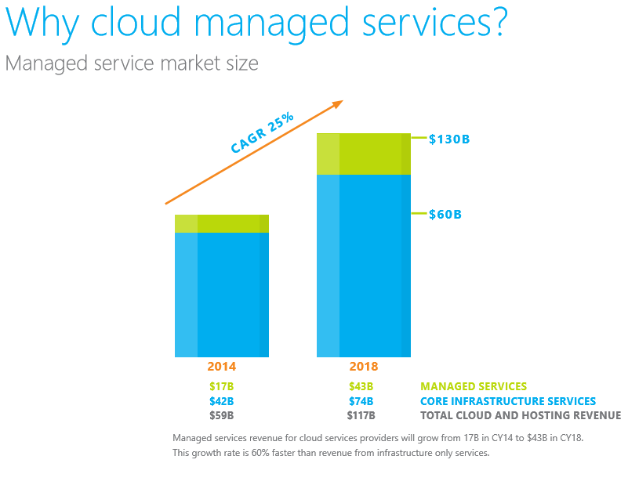

“Managed Services will suplant traditional consulting and value added services that are currently invoiced. The future of all business and business technology is pay-as-you-go subscriptions that allow you to pay only for what you want, and only when you need it. “

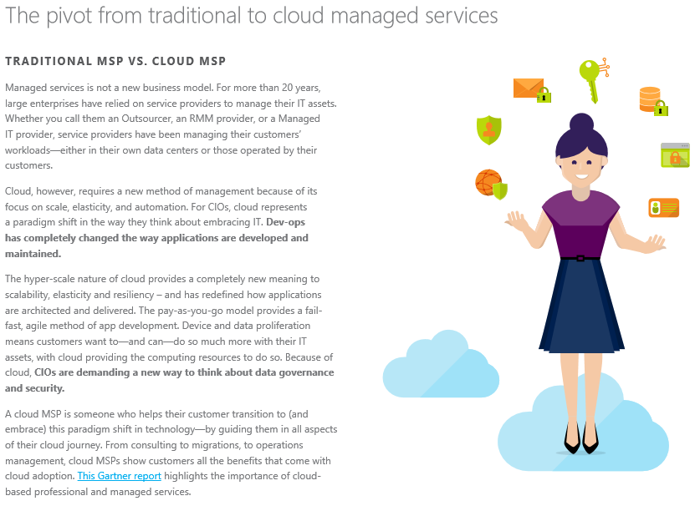

At the core of the RPTS Practice are the Pillars of our operations;

## 

## 

## RPTS Revenue Streams

There are several revenue stream that can be exploited in the MSP model that are unavailable in any other model. At the center of the MSP model is the concept of being a Digital Partner of Record (DPOR). A DPOR is required in order for Microsoft to coordinate access and administrative functions for clients who have designated us as their official Microsoft Partner. As a DPOR for our clients, the following revenue streams have been identified;

1. RPTS will receive ongoing revenue from Office 365 subscriptions once we become established as a client’s DPOR. Ongoing revenue from reselling Office 365 subscriptions is small at first, but will become a major source of ongoing revenue as the client base increases. Earning potential here is a product of the user base.
2. Value Added Services will replace “consulting”. RPTS will provide “consulting services” in a pay-as-you-go environment. These one-off-projects are invoiced.
3. Microsoft Community Connections Program / Partner Funding. We co-sponsor events with Microsoft and provide thought leadership and free advisory services from Microsoft. As their advisor we have ongoing opportunities to up-sell and provide value added services. In short, we get small one-off gigs from this and can “passively sell” our services as their “free MS Advisor”.
4. MPN Cross Selling and Small Business Set asides. We frequently find alignments and cross sell services from different partners. Our strategy is to formally establish partnerships with these providers and cross-sell Managed Services. Example: A payroll service that is incorporated directly into their Office 365 subscription service. In this scenario RPTS receives a residual income from vendors as we provide their subscription services to our client base. Another example: Help RPTS clients fulfill their small business set aside goals through B2B transactions within our “eco system”.
5. IT Managed Services that go beyond just being the DPOR. RPTS can add additional services to the client’s subscription fee that are paid directly to us via the Microsoft Paywall, including services beyond the traditional IT Managed Service. For example, our clients can subscribe to “*RPTS Silver Cybersecurity Services*” for $1 per person per month that is added to their existing Microsoft Subscription. Any service we offer can be a subscription through Microsoft.
6. Microsoft Store - An app from the Microsoft Store can be created for everything we do and utilized for every Microsoft customer on earth. This is the goal.

## Business Process Overview

There are 5 key systems of record to RPTS operations:

1. Partner Admin Console
2. RPTS Tenant Admin Console
3. NIST Assist Operations Portal
4. Security and Compliance Center for each Tenant
5. Eco Assist Add on for Security and Compliance Center for each Tenant

There are 4 key Consoles to the operations associated with MPN Management:

1. MPN Partner Console
2. Partner Center Dashboard
3. Partner Admin Center
4. Partner Membership Center

## Business Development Efforts (Clients / Partners)

* Ryan Wilderman
* WZC Networking
* Golden
* Rockwall Chamber of Commerce
* Valiant
* Microsoft
* PFC
* Excalibur
* Servidyne

## Paying Subscription Clients (MSP Clients)

* PFC
* Excalibur
* Golden
* WZC

## Clients / Partners Providing Income (Traditional Consulting)

* Akal Security
* Coastal Security
* PFC
* Excalibur
* Valiant
* Bridge Gap Technologies
* Servidyne

## Current Income Opportunities (proposed or in works)

|  |  |  |
| --- | --- | --- |
| **Client / Partner** | **Description** | **Potential** |
| Akal Security | SharePoint 2010 | $1,300.00/month |
| PFC | Managed Service | $500.00/month |
| Excalibur | Managed Service | $500.00/month |
| Valiant | Project | $2500.00 |
| Ryan Wilderman | Project | $3,500.00 |
| WZC Networking | Managed Service | $500.00/month |
| Bridge Gap | Managed Service | $2,000.00/month |
| Bridge Gap | Project | $5,000.00 |
|  | **Total Projects: $11,000** | **Total Monthly: $4,800** |

## How it Works:

We follow a very specific playbook when engaged with a client. This has been developed to focus first on Security and Compliance, and then moves into efficiency and Risk Management. Next, we focus on the “Ideal Desktop” as it relates to System Identification and Lifecycle Management. The playbooks for all engagements are not only curated but they are themselves Risk Management Control Measures. Playbooks are used to provide a roadmap of activities that are required for any given situation. This resembles a checklist that includes how to make your client more profitable and yourself more valuable and crucial to client profit by providing turnkey solutions that are fully integrated and secure within their physical or virtual environment.

RPTS will engage clients according to a stringent Microsoft Playbook that center on these core responsibilities:

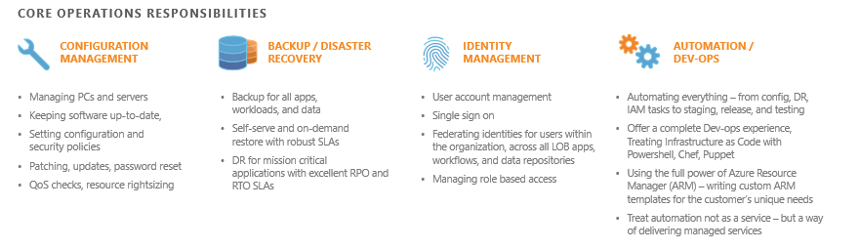

# RPTS Assets

## Asset Valuation Summary (depreciated)

|  |  |  |
| --- | --- | --- |
| **Virtual Assets** | **Description** | **Value / Cost** |
| Office 365 Software Licenses and Application Pool | Annual Licenses Purchased - All infrastructure is virtual including PBX and PSTN. Our capacity is 5 Global Administrators and 25 Technicians with unlimited Associates and Tenants. We are at 30% capacity. | $1,500.00 |
| Internal Use Rights | Action Pack Subscription | $500.00 |
| Trials and Vouchers | Annual License Credits | $1,000.00 |
| MPN / MCC | The Microsoft Partner Network and Microsoft Community Connections Program provide Annual License Allowance as a Membership Benefit – including marketing, technical support, Pinpoint, concierge service, and technical support | $15,000.00 |
| Azure | Azure and the Microsoft Cloud have unlimited virtual servers and server clusters. We no longer have servers in house. This is part of our Annual License Allowance. | $1,200.00 |
| Microsoft Development Environment with duplicate Azure Cloud front and backend fully configured and functional | Annual License Purchase | $2,500.00 |
| Remote Control and Customer Assistance Telemetry | Annual License Purchase | $1,100.00 |
| Administration and Back Office / Development Platform | Total investment in back office and development environment - This aggregated cost over 8 years where new enhancements are added by our IP. | $12,000.00 |
|  | **Total Value of MS Licensure** | **$34,800.00** |
|  |  |  |
| **Physical Assets** | **Description** | **Value** |
| 4 High-end Desktops and Development Workstations   * Video / Audio Production * SCORM Peripherals * Bar Coding and Scanning Peripherals * Software Research and Development | High-end hardware and software in unique configurations with redundancy and fail-safe mechanisms, multi boot - multi OS, RAID, etc. For testing and deploying, research and development of testing and monitoring techniques. | $12,000.00 |
| 6 Notebooks and tablets | Various brands for testing and hacking; HP, Dell, Microsoft | $1,800.00 |
| 2 Office Printers | HP, Epson | $400.00 |
| 3D Printer and 3D Design Studio with Software | XYZ Printer for prototyping, research and development | $1,100.00 |
| IoT Device Workstation | Research and Development for IoT and telemetry security | $500.00 |
| Drone / RC Workstation | Research and Development | $1,200.00 |
| Tech Bench Equipment / Counter Surveillance / Mobile Kits | Maintenance and Repair (mobile kits), security equipment like frequency counters, etc. | $3,500.00 |
| Networking Hardware and Equipment | Meters, tone testers, crimp tools, acc. (Mobile Kits for Transition) - RFID / Barcode / Card Swipe | $800.00 |
| Misc. Computer Hardware | Misc. peripherals, adapters, screens, devices | $1,800.00 |
|  | **Total** | **$23,100.00** |
|  |  |  |
| **Real Intellectual Property** | **Description** | **Man Hours** |
| Microsoft Eco System and Azure Playbooks | 100’s of Certifications and Training over a decade | $12,000.00 |
| NIST Curated Material and Content | Man hours studying, researching and technical writing into Blocks | $8,000.00 |
| AIIM – Fantastic 40 | Database Architecture and Relational Database design in SharePoint. Software code and design elements for SharePoint Client Object Model, API’s, and Visual Studio | $5,000.00 |
| SQL Database | SQL Administration best practice | $1,500.00 |
| IoT | IoT Device research and prototyping | $2,000.00 |
| Software Development Lifecycle (SDLC) and SDLC Playbooks | Certifications and Competency from Microsoft that include validated projects of major release, developing on Android, IOS, PC, UWP, SQL, SharePoint, & Office 365 | $6,000.00 |
| NIST Cybersecurity Framework including 800-53 et al. | NIST and related frameworks - Cybersecurity procedures and remediation of a wide range of data loss scenarios including retrieval and countermeasures. Includes a decade of technical writing, contributions, technical articles and published open editorials within IT industry | $7,500.00 |
| Lean, Six Sigma, EVM | Curated content and related materials | $6,500.00 |
| Database of vulnerabilities and proprietary countermeasures | Private IP based on clients who have incidents that are not public and remediation that was not commercially available. This includes penetration testing and related activities. | $5,500.00 |
| PBX, VOIP, and PSTN Security and countermeasures | Includes real world experience and scenarios with related procedures to remediate risk | $5,000.00 |
| Identity Management Playbooks | Identity management techniques and related Cloud vulnerabilities that include research and development of row hammer exploits | $2,500.00 |
|  | **Total** | **$61,500.00** |
| **Human Resource Capital** | **Description** | **Value** |
| Marcel Murrell | Per hour profit | $25.00 |
| Rich Owens | Per hour profit | $20.00 |
| Greg Peck | Per hour profit | $25.00 |
| Eric Trybus | Per hour profit | $20.00 |
| Alex Domeracki | Per hour profit | $25.00 |
| Floyd Shipp | Per hour profit | $15.00 |
| Lance Gabel | Per hour profit | $15.00 |
| MPN Resources | Per hour profit | TBD |
| **Financials** |  |  |
| Total Asset Value | Total Depreciated Real Value | $119,400.00 |
| Monthly Burn Rate | Currently running at 30% capacity but paying for 100% | $3,500.00 |
| Average Monthly Income | Down tick last 2 months due to Akal | $8,000.00 |
| Average Yearly Net | Steady over 8 years | $50,000.00 |
| **Current Valuation** | Consulting Model | **2.5M** |
| **MSP Valuation** | Cloud Service Provider Model | **18M** |

## Microsoft Partner Network Advantages / Discriminators

As a Microsoft Partner we are empowered by Microsoft in many ways. In addition to one of the largest and most secure data centers in the world, we are provided playbooks, training, and VIP support which includes direct access to high level engineers and technicians. Additional advantages to franchising with Microsoft include, but are not limited to;

* The power of being able to talk to a customer as a representative of Microsoft, with Microsoft backing us up by honoring us as the clients dedicated provider of support services.
* 6 potential Revenue Streams that include more than one residual income based on subscription services that are coterminous with existing subscriptions.
* Marketing and campaign Resources that include content, presentations, and tutorials.
* Silver Competency that includes Internal Use Rights (IUR); RPTS will not have to pay for its own system within 6 months (savings of 6K annual).
* Lowest total Cost of Ownership (TCO) of any competitor. Competitors have a higher TCO due to legacy systems and existing data center costs because they are still moving to the Cloud.
* VIP Services from Microsoft that include Cybercrimes Monitoring and Concierge Services.
* Guidance, Enablement Desks, Partner Conferences, technical training and industry certifications.

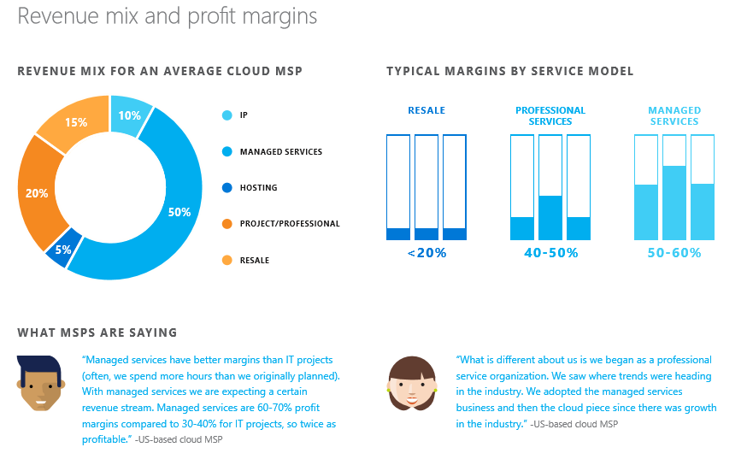

On average 120 thousand customers are moving to the Cloud per month. RPTS is projected to hit 250 seats by the end of 2016 with no sales and no marketing. Our goal is to get enough working capital to engage additional account executives that will increase our growth rate to 4000 users in 1 year.

|  |  |  |  |
| --- | --- | --- | --- |
| Monthly Seat Count | Amortized Cost | Profit Percentage | Monthly Net |
| 250 | $60.00 | 10% | $8,000.00 |
| 500 | $30.00 | 20% | $18,000.00 |
| 1000 | $15.00 | 40% | $38,000.00 |
| 2000 | $15.00 | 40% | $70,000.00 |
| Silver and Gold Competency |  |  | Monthly Gross |
| 2000 | $5.00 | 40% | $10,000.00 |
| 3000 | $2.50 | 40% | $25,000.00 |
| 4000 | $2.50 | 40% | $60,000.00 |

* Average monthly cost per user for companies who are not 100 %in the Cloud is approx. $70.00.
* Average cost for Cloud is approx. $35.00, and you get more for less.
* RPTS makes approx. $15.00/month per user on average, but could go as high as $35.00 per user on average depending on the nature and scope of the Managed Services Contract.
* With advanced Security and Compliance contracts, and a Gold Partnership with 4000 users, RPTS would gross 60K per month not including Value Added Services or traditional consulting revenue.